INFORMATION TECHNOLOGY INSTITUTE
Analog IC Design Track

Analog Integrated Circuit Design
Lab 08
Negative Feedback

Table of Contents
PART 1: Feedback with Behavioral OTA 3
1.1 Closed-Loop Gain vs. Frequency 4
1.1.1 Simulation Results: 4
1.1.2 Hand Analysis: 5
1.2 Loop gain vs frequency (STB Analysis): 6
1.2.1 Simulation Results: 6
1.2.2 Hand Analysis: 7
1.3 Gain Desensitization: 9
1.3.1 Simulation Results: 9
1.3.2 Hand Analysis: 10
2 PART 2: Feedback with Real 5T OTA 11
2.1 Closed-Loop Gain vs. Frequency 11
2.1.1 Simulation Results: 11
2.2 Loop gain vs frequency (STB Analysis): 13
2.2.1 Simulation Results: 13
2.3 Gain Desensitization: 14
2.3.1 Simulation Results: 14
2.4 Transient analysis: 16
2.4.1 Simulation Results at $FIN=1$ kHz: 16
2.4.2 Simulation Results at $FIN=BWCL$ ($1.773$ MHz): 18

PART 1: Feedback with Behavioral OTA
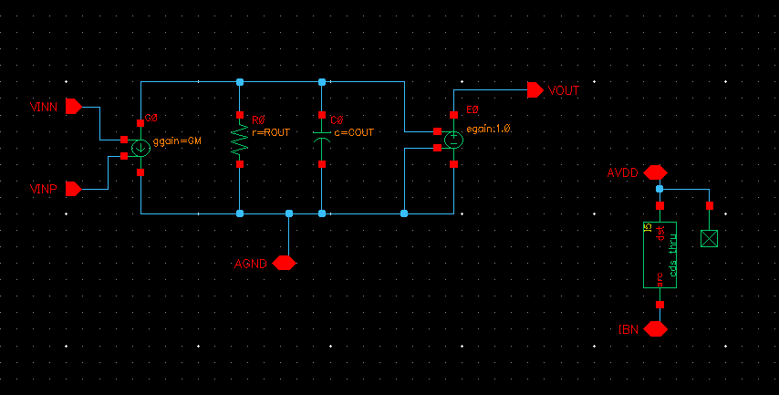
Figure 1: Behavioral Model Schematic
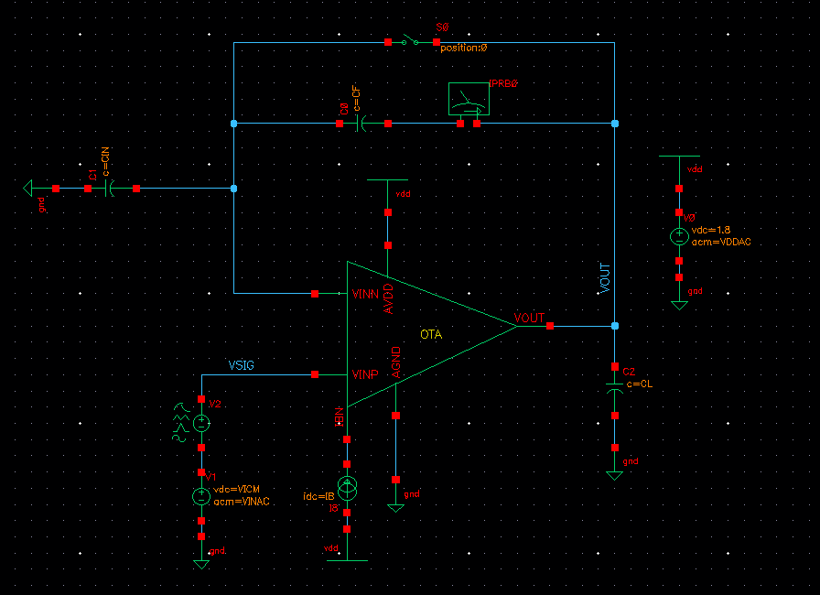
Figure 2: Testbench Schematic

$$R_{OUT}=\frac{A_{v}}{GM}=\frac{65}{157.3 μA/V}=414\text{ k}Ω$$
$$C_{OUT}=\frac{GM}{ω_{u}}=\frac{157.3 μA/V}{2π\left(5.0081 \text{MHz}\right)}=5.0\text{ pF}$$
  - Closed-Loop Gain vs. Frequency
    - Simulation Results:
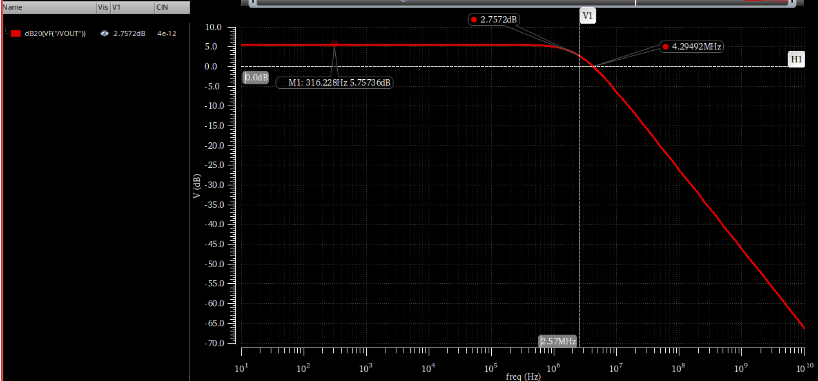
Figure 3: VOUT in dB with Cin=4pF
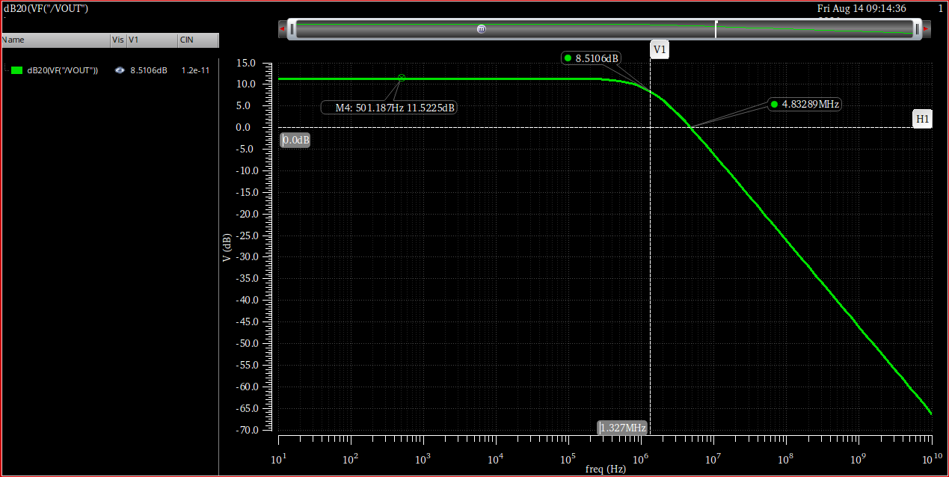
Figure 4: VOUT in dB with Cin=12pF

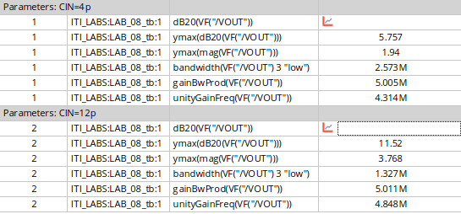
Figure 5: All Simulation Results for AC closed loop
Table 1: Simulation Results
Parameters | Cin = 4pF | Cin = 12pF
DC Gain in dB | 5.757 | 11.52
DC Gain | 1.94 | 3.768
BW | 2.573 MHz | 1.327 MHz
GBW | 5 MHz | 5 MHz
UGF | 4.314 MHz | 4.848 MHz

    - Hand Analysis:
From the Lab 7 simulation results, the behavioral OTA parameters are modeled as follows:
- Open-Loop DC Gain ($A_{OL}$) = $36.13$ dB ($65$ V/V)
- Open-Loop Bandwidth ($BW_{OL}$) = $76.1$ kHz
- Open-Loop Gain-Bandwidth Product ($GBW_{OL}$) = $4.9$ MHz
$$Ideal \text{closed loop }Gain=1+\frac{C_{IN}}{C_{F}}$$
The feedback factor :
$$β=\frac{C_{F}}{C_{F}+C_{IN}}$$
So
$$A_{CL}=\frac{A_{OL}}{1+βA_{OL}}$$
$$BW_{CL}=BW_{OL}×\left(1+βA_{OL}\right)$$
For $C_{IN}$ = 4pF:
- $β=\frac{4\text{pF}}{4\text{pF}+4\text{pF}}=0.5$
- Ideal Gain = $1+\frac{4\text{pF}}{4\text{pF}}=2$ V/V ($6.02$ dB)
- $A_{CL}=\frac{65}{1+\left(0.5×65\right)}=1.94$ V/V ($5.75$ dB)
- $BW_{CL}=76.1\text{ kHz}×\left(1+32.5\right)=2.55$ MHz
For $C_{IN}$ = 12pF:
- $β=\frac{4\text{pF}}{4\text{pF}+12\text{pF}}=0.25$
- Ideal Gain = $1+\frac{12\text{pF}}{4\text{pF}}=4$ V/V ($12.04$ dB)
- $A_{CL}=\frac{65}{1+\left(0.25×65\right)}=3.768$ V/V ($11.51$ dB)
- $BW_{CL}=76.1\text{ kHz}×\left(1+16.25\right)=1.31$ MHz

Table 2: Closed-Loop AC Parameters – Hand Calculation vs. Simulation
Parameter | Cin = 4PF |  | Cin = 12pF
 | Simulation | Analytical | Simulation | Analytical
DC Gain in dB | 5.757 dB | 5.75 dB | 11.52 dB | 11.51 dB
DC Gain | 1.94 | 1.94 | 3.768 | 3.764
BW | 2.573 MHz | 2.51 MHz | 1.327 MHz | 1.3 MHz
GBW | 5 MHz | 4.95 MHz | 5 MHz | 4.94 MHz

Comment on the difference between the results for the two values of CIN.
Increasing Cin decreases the feedback factor to the half which in approx. it doubles the closed loop gain while halving the BW and the GBW is unchanged.
  - Loop gain vs frequency (STB Analysis):
    - Simulation Results:
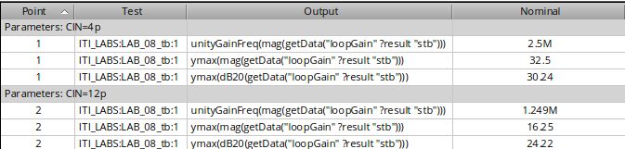
Figure 6: STB Analysis Results
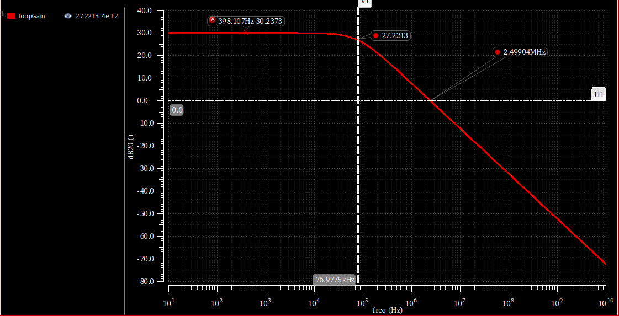 Figure 7: Loop gain magnitude vs. frequency for $C_{IN}$ = 4pF
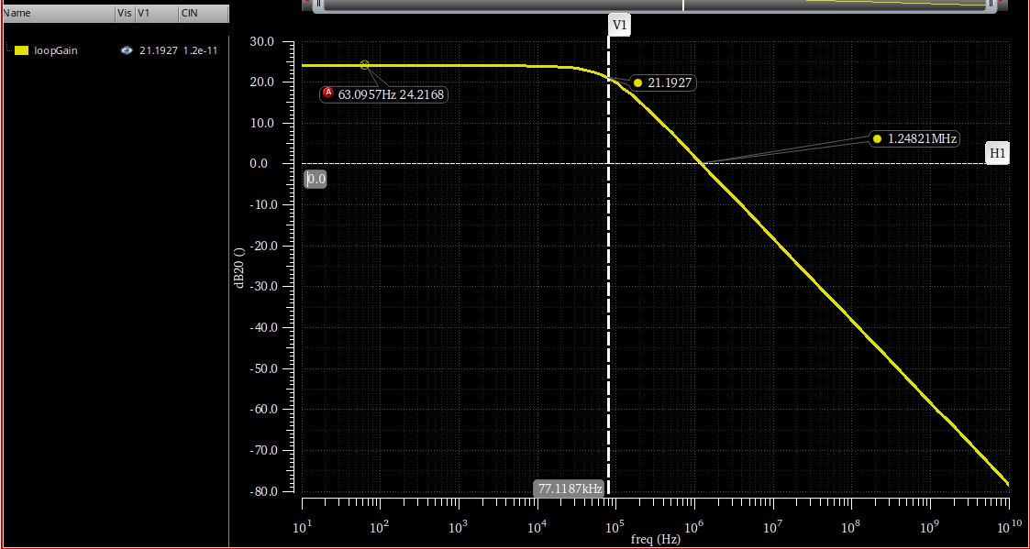 Figure 8: Loop gain magnitude vs. frequency for $C_{IN}$ = 12pF
    - Hand Analysis:
From the Lab 7 open-loop parameters, we have:
- Open-Loop DC Gain ($A_{OL}$) = $65$ V/V
- Open-Loop Bandwidth ($BW_{OL}$) = $76.1$ kHz
- Open-Loop Gain-Bandwidth Product ($GBW_{OL}$) = $4.9$ MHz

$$LG=β×A_{OL}$$
The dominant pole is the same as open loop pole:
$$Pole_{dominant}=BW_{OL}=76.1 KHz$$
The UGF is scaled with feedback factor
$$UGF_{LG}= β×GBW_{OL}$$

For $C_{IN}$ = 4pF:
- $β=0.5$
- $LG=0.5×65=32.5$ V/V ($30.24$ dB)
- $Pole_{dominant}=76.1$ kHz
- $UGF_{LG}=0.5×4.9\text{ MHz}=2.45$ MHz
For $C_{IN}$ = 12pF:
- $β=0.25$
- $LG=0.25×65=16.25$ V/V ($24.22$ dB)
- $Pole_{dominant}=76.1$ kHz
- $UGF_{LG}=0.25×4.9\text{ MHz}=1.225$ MHz

Table 3: Loop Gain Parameters – Hand Calculation vs. Simulation
Parameter | Cin = 4PF |  | Cin = 12pF
 | Simulation | Analytical | Simulation | Analytical
DC Loop Gain in dB | 30.24 dB | 30.24 dB | 24.22 dB | 24.22 dB
DC Loop Gain | 32.5 | 32.51 | 16.25 | 16.255
BW | 77 MHz | 76.1 MHz | 76.9 MHz | 76.1 MHz
UGF | 2.5 MHz | 2.45 MHz | 1.25 MHz | 1.225 MHz

Comment on the differences between the results for the two values of $C_{IN}$.
Increasing $C_{IN}$ from 4pF to 12pF reduces the feedback factor $β$ by half, halving the feedback factor causes the DC loop gain to drop by a factor of 2 (a $6$ dB decrease) and also halves the unity gain frequency ($UGF$) of the loop. However, because the feedback network is an ideal capacitive voltage divider, it does not alter the frequency response characteristics of the OTA itself, meaning the dominant pole remains constant at approximately $76.1$ kHz for both cases.

  - Gain Desensitization:
    - Simulation Results:
As I don’t have Av as a variable in the behavioral circuit I only have GM and Rout so I will sweep over one of them
$$A_{OL}=GM×ROUT$$
To sweep over GM, Rout = 414 k
Start: $GM=\frac{Av}{ROUT}=\frac{50}{414 k}=120$µA/V (${10}^{-4}$ S)
End : $GM=\frac{Av}{ROUT}=\frac{50000}{414 k}=120 m$A/V (${10}^{-4}$ S)
To sweep over Rout, GM = 157 u
Start: $ROUT=\frac{Av}{GM}=\frac{50}{157 u}=320 KΩ$
End: $ROUT=\frac{Av}{GM}=\frac{50000}{157 u}=320 MΩ$

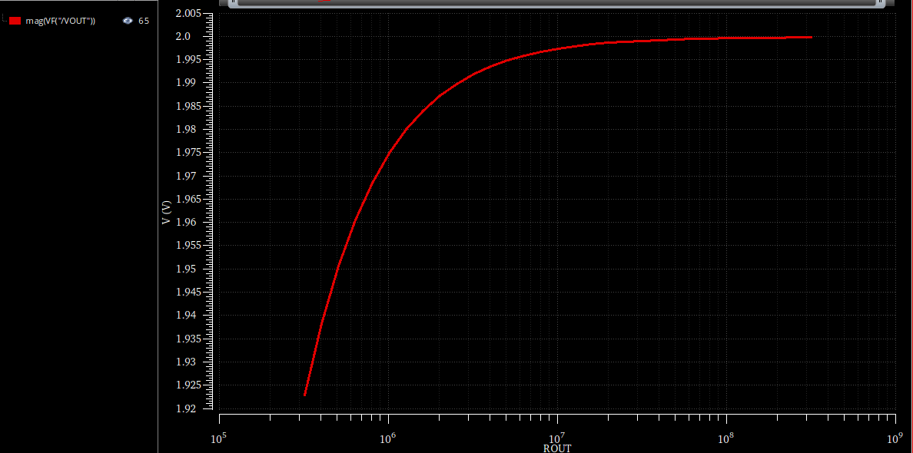
Figure 9: Closed-loop DC gain magnitude vs. ROUT sweep.
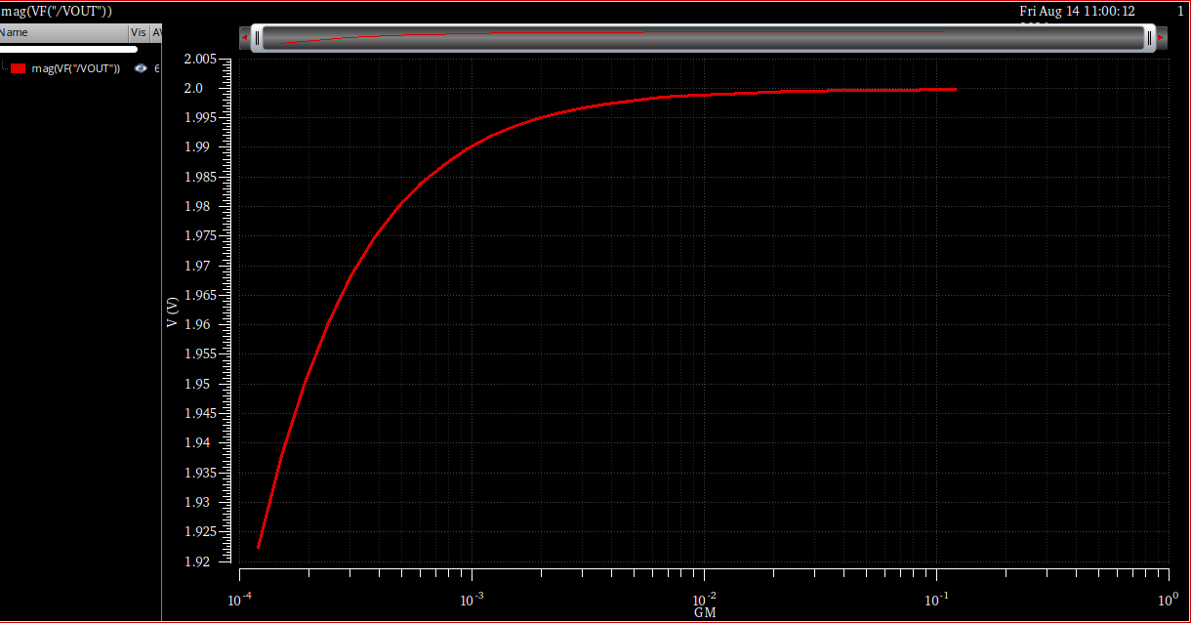
Figure 10: Closed-loop DC gain magnitude vs. GM sweep
    - Hand Analysis:
$$A_{CL}=\frac{A_{OL}}{1+βA_{OL}}$$
$$A_{cl}=50/26=1.923$$
$$A_{cl}=50000/25001=1.99996$$
$$\% ΔA_{cl}=\frac{1.99996-1.923}{1.923}×100\%≈4.0\%$$
Just a change 4 percent while the open loop changed 1000 times which is 60dB, the closed-loop gain sensitivity to open-loop gain is suppressed by roughly the same factor as the loop gain itself this is the core of desensitization: $\frac{dA_{cl}/A_{cl}}{dA_{v}/A_{v}}=\frac{1}{1+βA_{v}}$, which shrinks toward zero as loop gain grows.

- PART 2: Feedback with Real 5T OTA
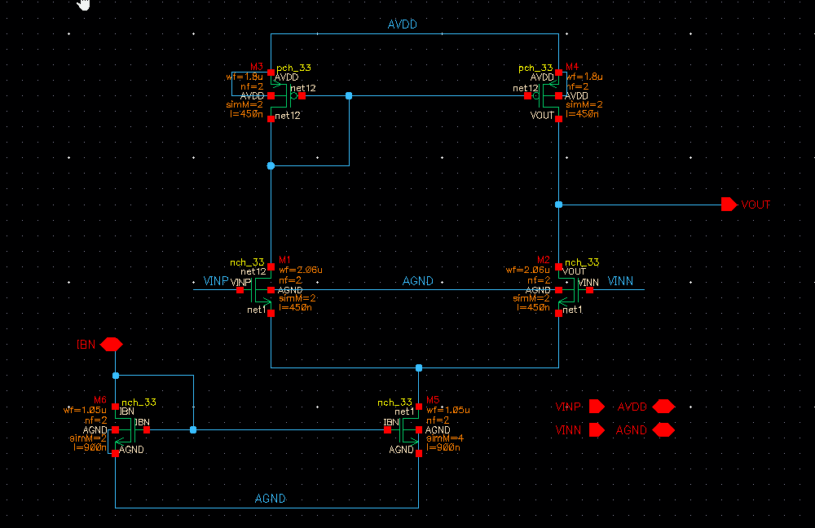
Figure 11: Real 5T OTA schematic
  - Closed-Loop Gain vs. Frequency
    - Simulation Results:
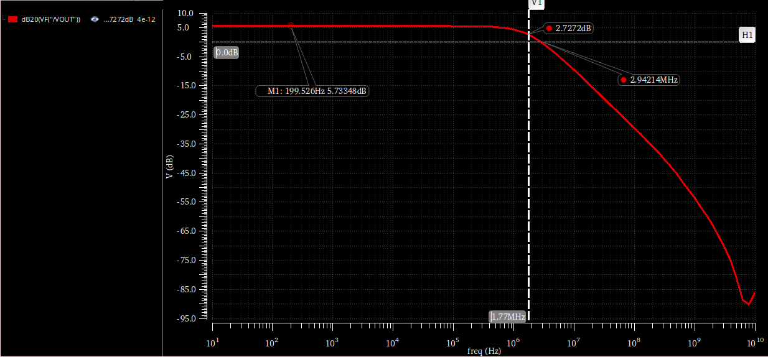
Figure 12: VOUT in dB with Cin=4pF
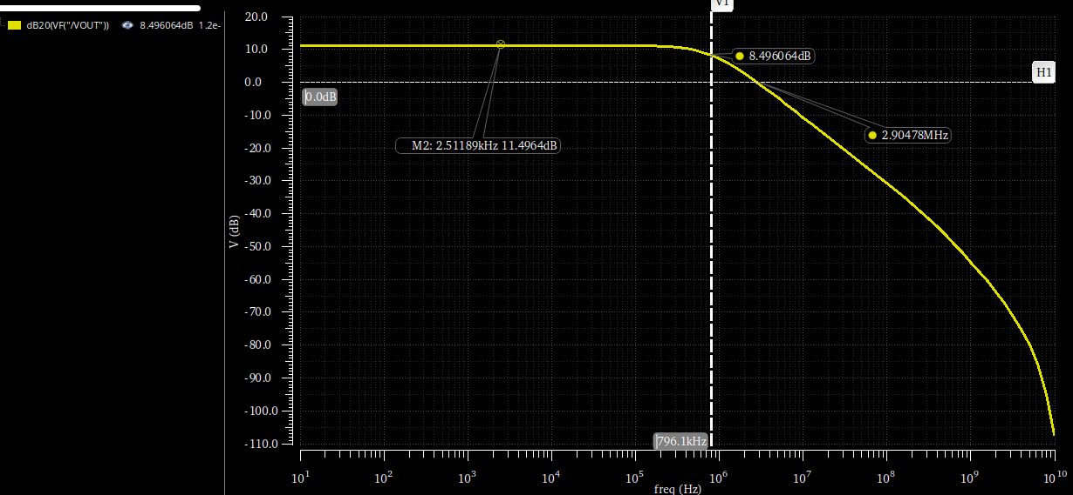
Figure 13: VOUT in dB with Cin=12pF

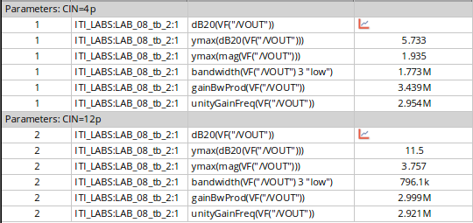
Figure 14: All Simulation Results for AC closed loop
Table 4: Closed-Loop AC Parameters – Behavioral vs Real OTA
Parameter | Cin = 4PF |  | Cin = 12pF
 | Behavioral OTA | Real OTA | Behavioral OTA | Real OTA
DC Gain in dB | 5.757 dB | 5.733 dB | 11.52 dB | 11.5 dB
DC Gain | 1.94 | 1.94 | 3.768 | 3.757
BW | 2.573 MHz | 1.773 MHz | 1.327 MHz | 796.1 kHz
UGF | 4.314 MHz | 2.954 MHz | 4.85 MHz | 2.921 MHz
GBW | 5 MHz | 3.439 MHz | 5 MHz | 3 MHz

Comment on the differences between Behavioral and Real OTA results.
The simulated closed-loop DC gains for the real 5T OTA matches the behavioral model. However, the bandwidth and Gain-Bandwidth Product (GBW) are smaller in the real OTA and this was expected. This occurs because the behavioral model utilized an ideal buffer at its output, which completely prevented the capacitive feedback network from loading the OTA. Also in the real 5T OTA ($C_{F}$ in series with $C_{IN}$) directly loads the output node, adding to the existing load capacitance ($C_{L}$) and the parasitic & internal caps of MOSFETS. This increased total capacitive loading lowers the dominant pole frequency, reducing both the closed-loop bandwidth and the overall GBW.
  - Loop gain vs frequency (STB Analysis):
    - Simulation Results:
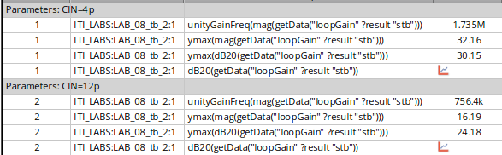
Figure 15: STB Analysis Results
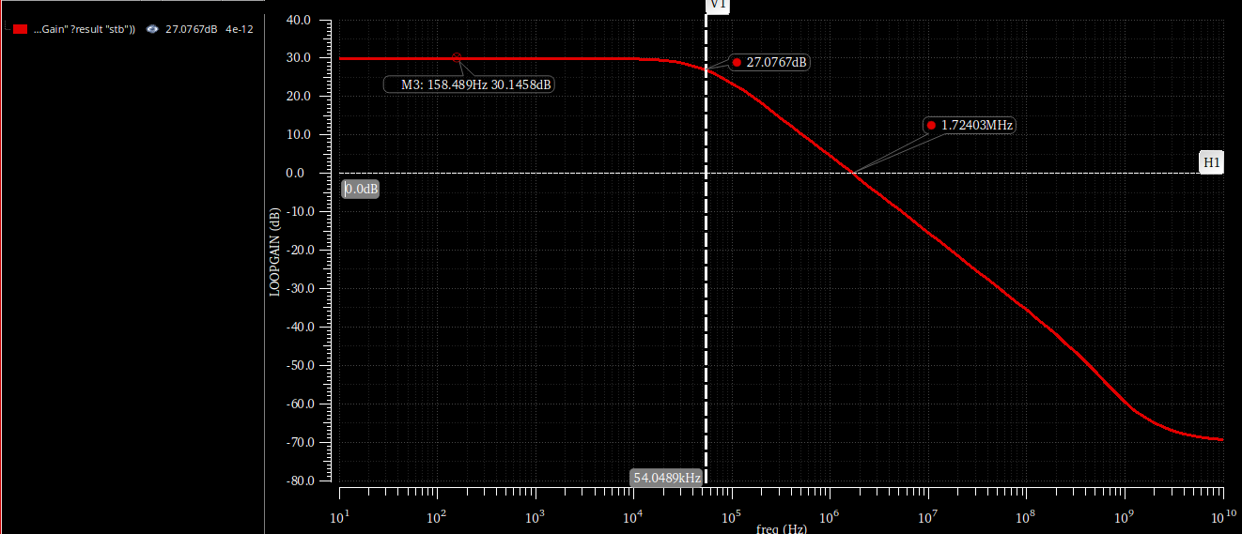
Figure 16: Loop gain magnitude vs. frequency for $C_{IN}$ = 4pF
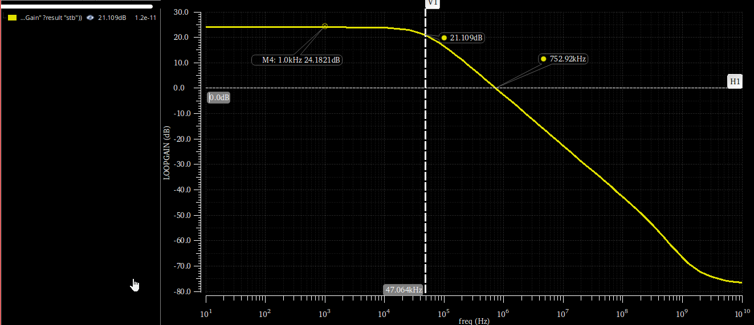
Figure 17: Loop gain magnitude vs. frequency for $C_{IN}$ = 12pF
Table 5: Loop Gain Parameters – Behavioral vs. Real OTA
Parameter | Cin = 4PF |  | Cin = 12pF
 | Behavioral | Real | Behavioral | Real
DC Loop Gain in dB | 30.24 dB | 30.15 dB | 24.22 dB | 24.18 dB
DC Loop Gain | 32.5 | 32.16 | 16.25 | 16.19
BW | 77 MHz | 54 MHz | 76.9 MHz | 47 MHz
UGF | 2.5 MHz | 1.735 MHz | 1.25 MHz | 756.4 kHz

Comment on the differences between Behavioral and Real OTA results:
The unity gain frequency (UGF) and the dominant pole of the loop gain are smaller in the real 5T OTA compared to the behavioral model. This is due to the same loading effect observed in the closed-loop AC response. The behavioral model uses an ideal buffer that isolates the feedback network ($C_{F}$ and $C_{IN}$) from the OTA's output. In the real transistor-level design, the feedback network acts as an additional capacitive load connected to the output node. Because the dominant pole is inversely proportional to the total output capacitance ($f_{p}∝1/C_{total}$), this extra loading shifts the dominant pole to a lower frequency (dropping from $76.1$ kHz down to the $47$-$54$ kHz range). Since the loop's UGF is approximately the product of the feedback factor ($β$) and the open-loop Gain-Bandwidth Product ($GBW$), the reduced $GBW$ from the heavier capacitive load directly results in a proportionally smaller loop gain UGF.
  - Gain Desensitization:
    - Simulation Results:
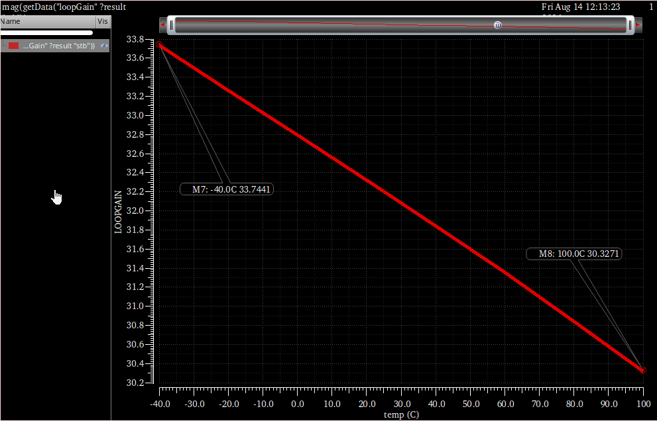
Figure 18: DC loop gain magnitude (linear) vs. temperature sweep
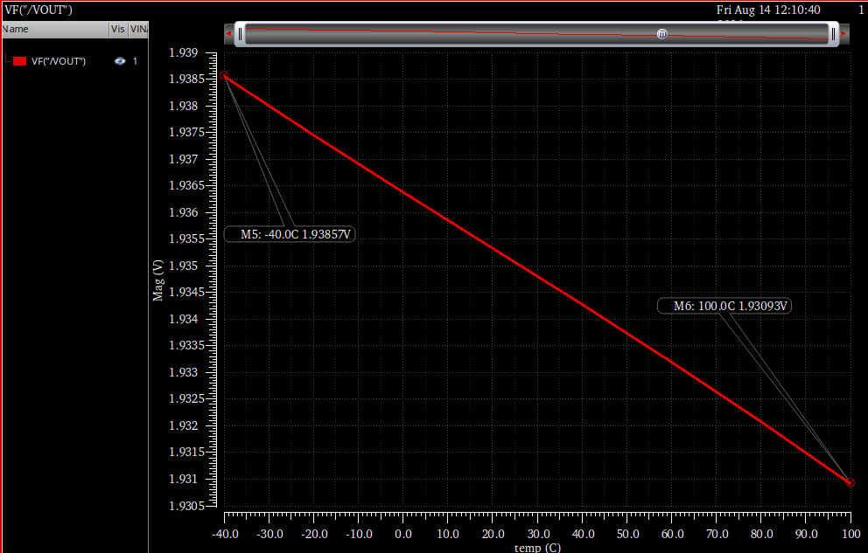
Figure 19: Closed-loop DC gain magnitude (linear) vs. temperature sweep.
From the STB analysis (Loop Gain):
- Maximum Loop Gain (at -40°C): 33.7441 V/V
- Minimum Loop Gain (at 100°C): 30.3271 V/V
- Percent Change: $\frac{33.7441-30.3271}{30.3271}×100$ = 11.27%
From the AC analysis (Closed-Loop Gain):
- Maximum Closed-Loop Gain (at -40°C): 1.93857 V/V
- Minimum Closed-Loop Gain (at 100°C): 1.93093 V/V
- Percent Change: $\frac{1.93857-1.93093}{1.93093}×100$ = 0.40%
Comment on Gain Desensitization with Temperature:
The simulation results clearly show the gain desensitization of negative feedback under physical variations. Temperature impact transistor characteristics (mobility and threshold voltage), causing the open-loop gain and the loop gain of the real 5T OTA to vary by 11.27% across the swept range. However, because the system is placed in closed-loop negative feedback, this is suppressed, resulting in a 0.40% change in the actual closed-loop gain. This confirms that the closed-loop performance is highly stable and defined by the passive feedback components rather than the active amplifier variations.
  - Transient analysis:
    - Simulation Results at $F_{IN}=1$ kHz:
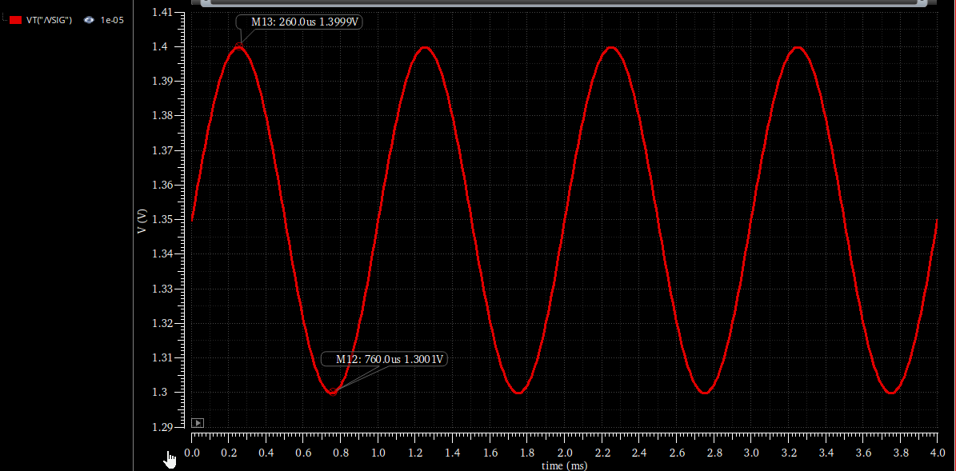
Figure 20: Transient input signal ($V_{IN}$) at $1$ kHz.
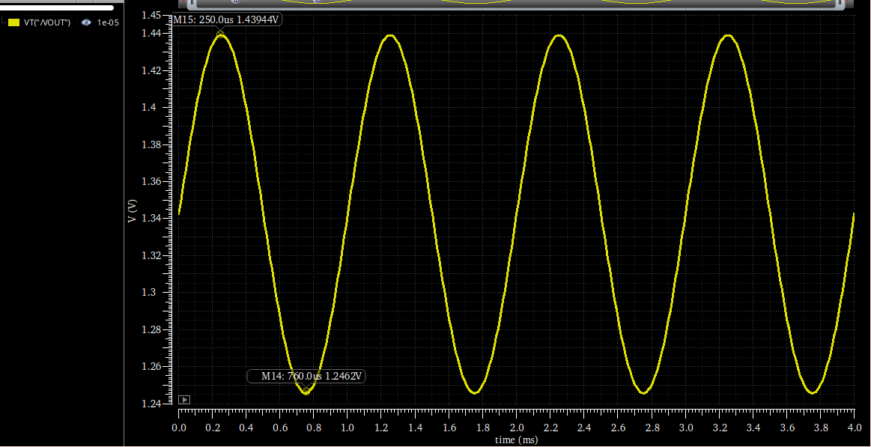
Figure 21: Transient output signal ($V_{OUT}$) at $1$ kHz.

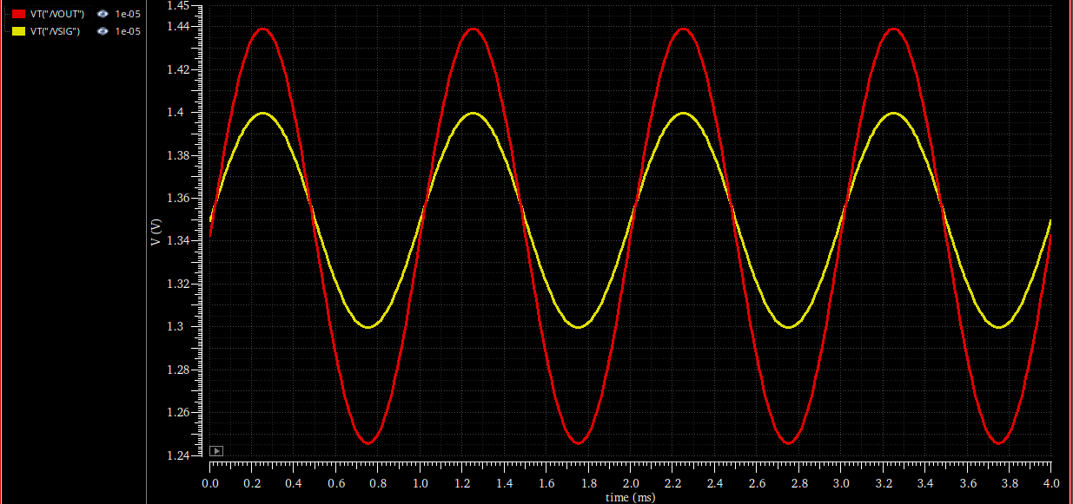
Figure 22: Transient input and output signals overlaid at $1$ kHz.
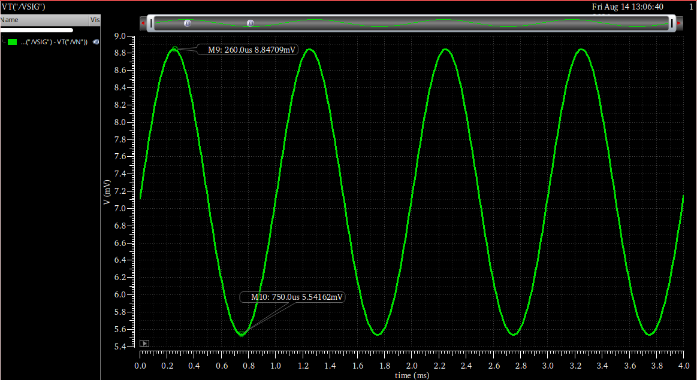
Figure 23: Differential input signal ($V_{P}-V_{N}$) at $1$ kHz.
Input $V_{IN}$ ($V_{pp}$)$= 100.0$ mV
Output $V_{OUT}$ ($V_{pp}$)$= 193.24$ mV
Differential Input $V_{P}-V_{N}$ ($V_{pp}$)$≈3.31$ mV

    - Simulation Results at $F_{IN}=BW_{CL}$ ($1.773$ MHz):
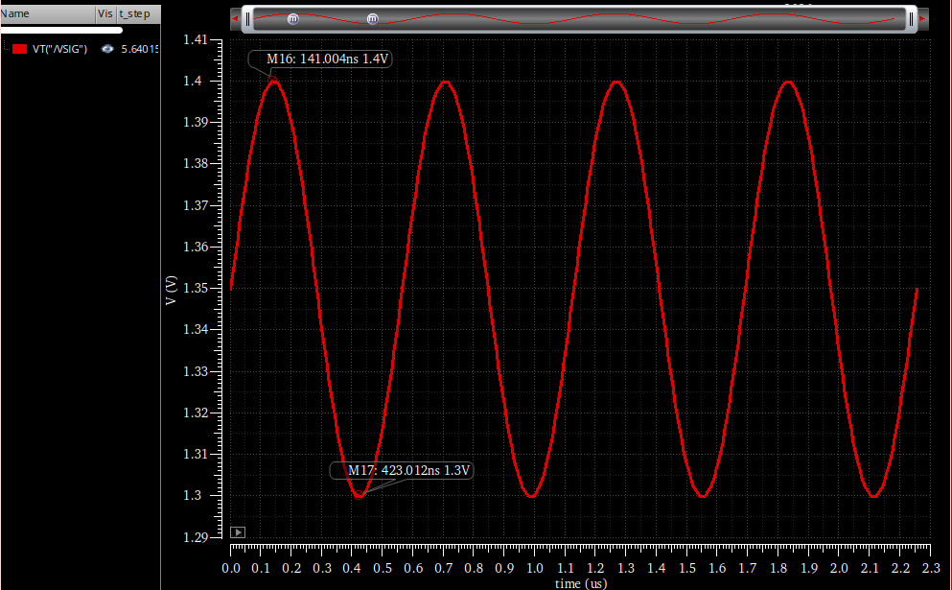
Figure 24: Transient input signal ($V_{IN}$) at $1.773$ MHz
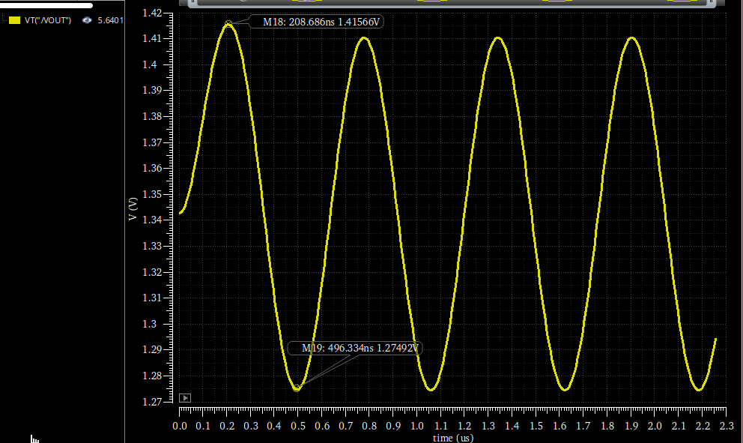
Figure 25: Transient output signal ($V_{OUT}$) at $1.773$ MHz.
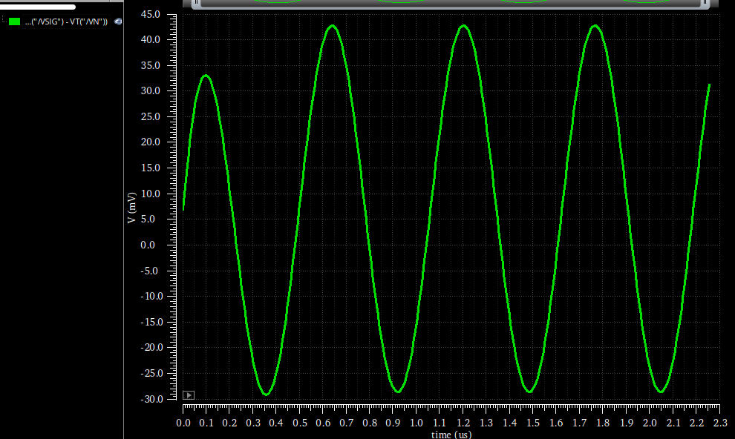
Figure 26: Differential input signal ($V_{P}-V_{N}$) at $1.773$ MHz.
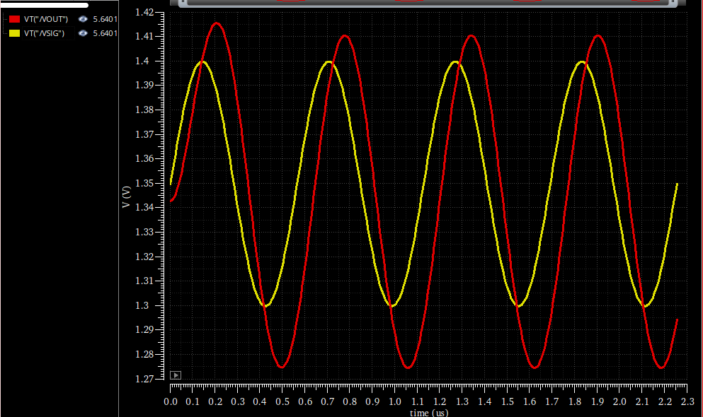
Figure 27: Transient input and output signals overlaid at $1.773$ MHz.

Input $V_{IN}$ ($V_{pp}$)$= 100.0$ mV
Output $V_{OUT}$ ($V_{pp}$)$= 140.74$ mV
Differential Input $V_{P}-V_{N}$ ($V_{pp}$)$≈72.0$ mV

Relation | FIN = 1 kHz | FIN = 1.773 MHz
Closed-Loop Gain ($V_{OUT,pp}/V_{IN,pp}$) | $$1.93$$ | $$1.41$$
Open-Loop Gain ($V_{OUT,pp}/V_{vid,pp}$) | $$58.4$$ | $$1.95$$

Comment on Transient Relations:
The relation between the output signal and the differential input signal ($V_{P}-V_{N}$) represents the open-loop gain of the OTA:
- At 1 kHz: The OTA operates well within its bandwidth, exhibiting its full open-loop DC gain (calculated here as $58.4$ V/V). Because the open-loop gain is high, the negative feedback is very strong, forcing the differential input voltage ($V_{P}-V_{N}$) to remain extremely small ($≈3.31$ mV). The resulting closed-loop gain is $1.93$ V/V, which tracks the ideal theoretical gain of 2 V/V.
- At 1.773 MHz ($BW_{CL}$): At this much higher frequency, the open-loop gain of the OTA rolls off significantly due to the dominant pole. With the open-loop gain dropping to approximately $1.95$ V/V, the negative feedback loop loses its effectiveness. As a result, the virtual short between the input terminals breaks down, causing the differential input voltage ($V_{P}-V_{N}$) to swing massively to $≈72.0$ mV. The closed-loop gain drops to $1.41$ V/V (which is $1.93/\sqrt{2}$). At this high frequency, the open-loop and closed-loop asymptotes coincide, leading to the open-loop and closed-loop gains becoming almost identical.

